FLIGHT FINDER PROJECT REPORT

1. INTRODUCTION
1.1 Project Overview
The project titled "Flight Finder – Smart Flight Search and Booking System" aims to provide a seamless platform for users to search, compare, and book domestic and international flights. It simplifies the travel booking experience with features such as real-time flight availability, fare comparisons, secure payments, booking management, and notification alerts. Flight operators can manage flight listings, availability, and pricing through a dedicated dashboard, while admins oversee overall system performance and integrity.
This system eliminates the traditional challenges of manual booking and helps users make quicker and more informed travel decisions.
1.2 Purpose
The purpose of this project is to provide an intuitive and efficient digital flight booking platform that connects travelers with trusted flight operators. It ensures:
- Easy and fast flight bookings
- Real-time fare and availability tracking
- Personalized user experience with travel history
- Secure and verified payment processing

2. IDEATION PHASE
2.1 Problem Statement
Travelers face difficulty finding reliable flights due to non-transparent fare systems, outdated booking interfaces, and lack of real-time updates on availability.
How Might We:
How might we help users search and book the best flights based on real-time prices, timing, and preferences?
2.2 Empathy Map Canvas
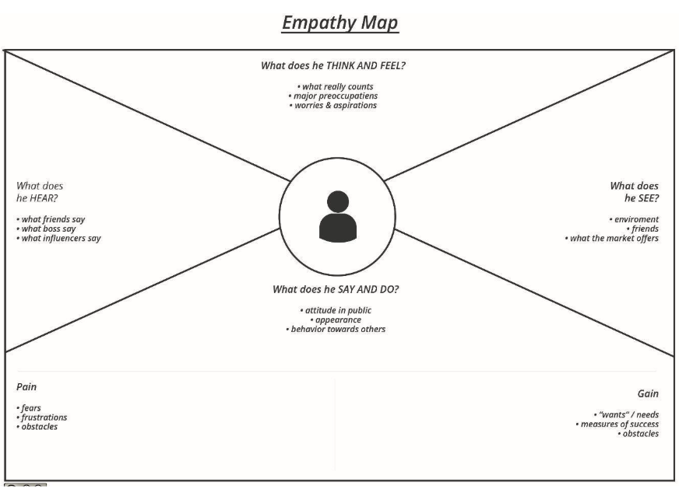
Says | “I want to compare flight prices easily and book without hassle.”
Thinks | “What if the flight gets cancelled or prices drop after booking?”
Feels | Confused by inconsistent pricing, anxious about missing better options
Does | Searches across multiple platforms, takes screenshots to compare later
2.3 Brainstorming
During the brainstorming session, the team proposed features like:
- Real-time search and filter by price, timing, and airline
- Price drop alerts and fare predictions
- Travel history and downloadable tickets
- Admin portal for managing operators and listings

3. REQUIREMENT ANALYSIS
3.1 Customer Journey Map
Stage | Action
Awareness | User discovers the Flight Finder app via search or referral
Registration/Login | User signs up or logs in securely
Flight Search | Enters source, destination, date, and filters
Booking & Payment | Selects preferred flight, completes payment
Confirmation | Receives confirmation via email/SMS
Post-Trip Follow-up | Can review the trip, download invoice, or file support requests
3.2 Solution Requirement
Functional Requirements:
- User registration and login (user/operator/admin)
- Search/filter flights based on various criteria
- Book/reschedule/cancel flights
- Secure online payment and ticket generation
- Admin dashboard for listing and user moderation
Non-Functional Requirements:
- Fast search and booking (<2 seconds)
- High uptime (99.9%)
- Secure data handling (SSL encryption, JWT tokens)
- Mobile-first design
- Scalable to support peak-time traffic
3.3 Data Flow Diagram (Level 0 DFD)
External Entities: User, Flight Operator, Admin
Processes: Authentication, Flight Search, Booking, Payment, Notification
Data Stores: User DB, Flights DB, Bookings DB, Payment Records
3.4 Technology Stack
- Frontend: React.js (Web), Flutter (Mobile – Future)
- Backend: Node.js with Express
- Database: MongoDB Atlas / PostgreSQL
- Authentication: JWT / Firebase Auth
- Hosting: Render / Vercel / AWS EC2

4. PROJECT DESIGN
4.1 Problem-Solution Fit
The platform solves the problem of inefficient and confusing flight bookings by offering an all-in-one flight search and booking system with real-time results, instant ticketing, and a user-focused interface.
4.2 Proposed Solution
A web and mobile-friendly application where:
- Travelers can easily search, book, and manage flight bookings
- Flight operators can upload listings and manage availability
- Admins monitor user activity and listings to ensure platform quality
4.3 Solution Architecture
Architecture Type: 3-Tier Client-Server Model
Layers:
- Presentation Layer: Responsive Web UI for users and operators
- Business Logic Layer: REST API for search, bookings, payments
- Data Layer: Flight listings, user profiles, booking records

5. PROJECT PLANNING & SCHEDULING
5.1 Project Planning
Agile methodology was adopted with sprints of 2–3 days each:
Sprint | Duration | Deliverables
Sprint-1 | 16 July – 17 July 2025 | Environment setup, auth system, landing page
Sprint-2 | 18 July – 19 July 2025 | Flight search and filter functionality
Sprint-3 | 20 July – 23 July 2025 | Booking module and profile management
Sprint-4 | 24 July – 26 July 2025 | Payment integration, notifications, testing

6. FUNCTIONAL AND PERFORMANCE TESTING
6.1 Performance Testing
Tools Used:
- JMeter – for simulating concurrent users
- Postman – for testing RESTful APIs
Test Scenarios:
- Simulated 200 concurrent users
- Tested booking and search modules under load
- Validated average response time under traffic
Results:
- Flight search average load time: 1.4 seconds
- Booking success rate under load: 98%
- No significant bottlenecks or downtime detected

7. RESULTS

7.1 Output Screenshots:
HOME PAGE :
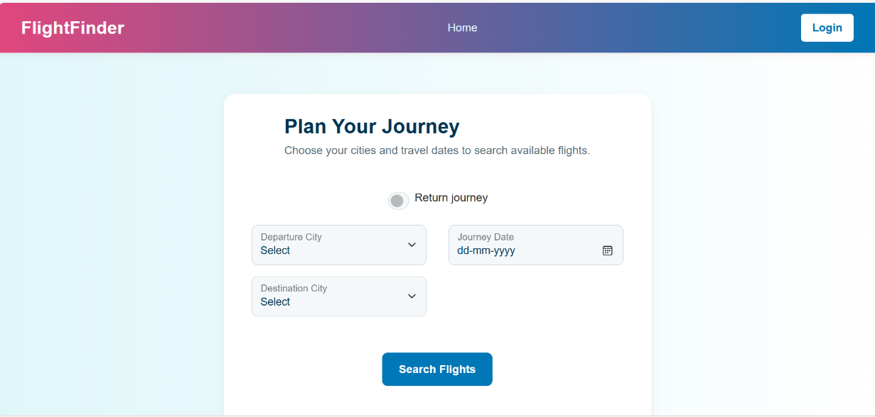

LOGIN PAGE:
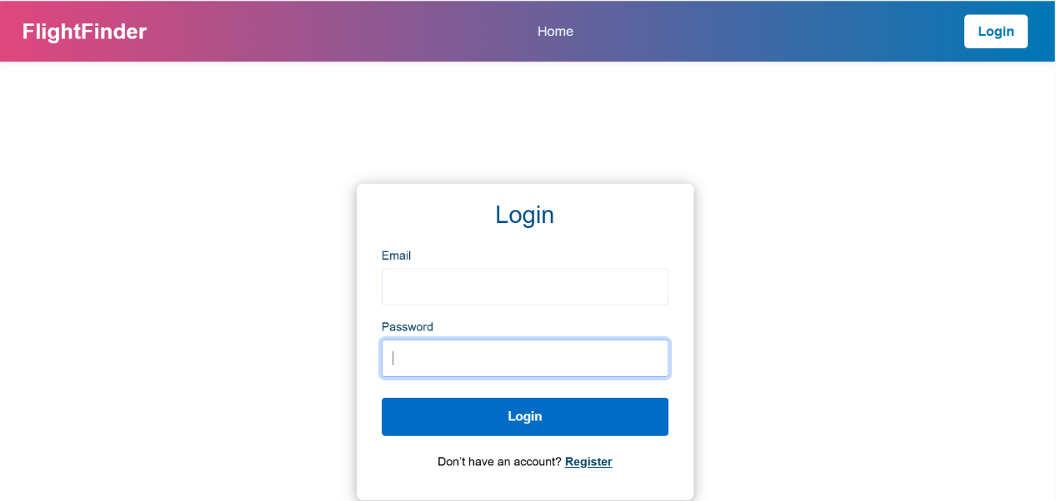

REGISTER PAGE :
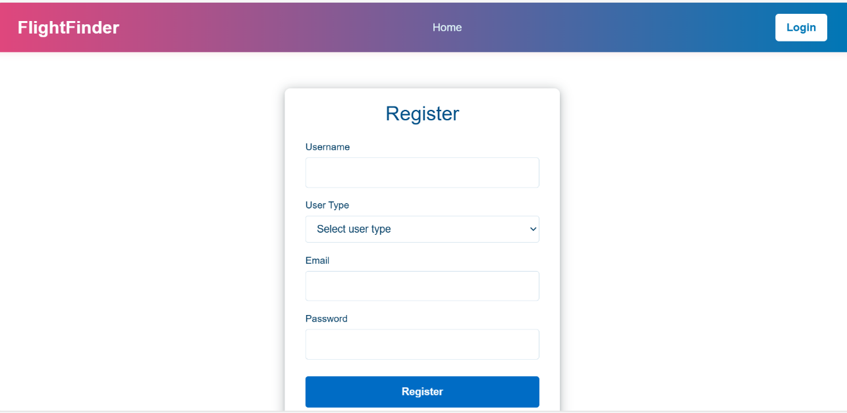

DASHBOARD:
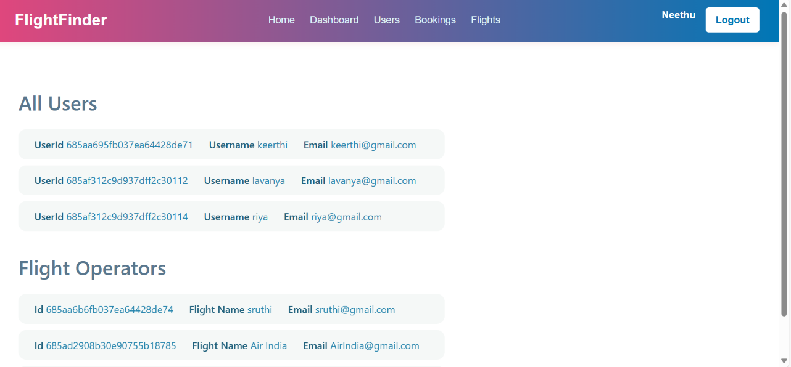

8. ADVANTAGES & DISADVANTAGES
Advantages:
- Saves time in searching and comparing flights
- Offers real-time pricing and availability
- Simplifies booking and payment processes
- Provides alerts for price drops and schedule changes
Disadvantages:
- Requires stable internet connectivity
- Initial development and API integration costs
- May involve learning curve for non-tech-savvy users

9. CONCLUSION
The Flight Finder project offers a modern and streamlined solution for booking flights across different airlines. It bridges the gap between travelers and airline operators by providing a centralized, efficient, and user-friendly platform. Leveraging real-time data, secure transactions, and responsive design, the system ensures high user satisfaction and operational efficiency.

10. FUTURE SCOPE
- Integration with real-time flight tracking APIs
- AI-based fare prediction and best-time-to-book engine
- Loyalty point system and frequent flyer support
- Multi-language and multi-currency compatibility
- Expansion to hotel and travel package bookings

11. APPENDIX
Source Code:
https://github.com/Chandrika2710/Flight-Finder

